Resources on Asian and Pacific Island Catholics from the United States Conference of Catholic Bishops (USCCB)

Get your copy by contacting scapa@usccb.org. $4/copy, check pay to: Asian and Pacific Island Affairs. The USCCB Subcommittee on Asian and Pacific Island Affairs is actively working on having more books on other Asian and Pacific

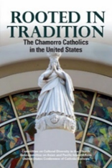

Rooted in Tradition: The Chamorro Catholics in the United States

A people indigenous to the Mariana Islands in the western Pacific, the Chamorros have a strong Catholic heritage, which they brought with them to the United States. This portrait of the Chamorro Catholics in the United States reveals the character and strength of their Catholic faith.

